**Exercise 5: Triggers**

**Scenario 1: Automatically update the last modified date when a customer's record is updated.**

**Question: Write a trigger UpdateCustomerLastModified that updates the LastModified column of the Customers table to the current date whenever a customer's record is updated.**

Trigger Creation

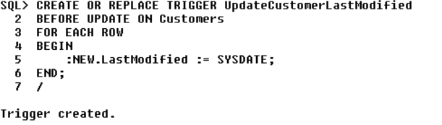

Testing the trigger

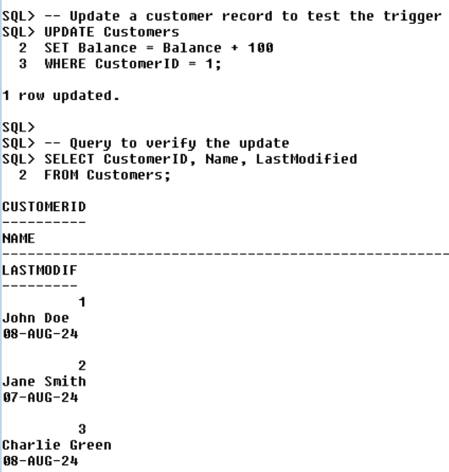

**Scenario 2: Maintain an audit log for all transactions.**

**Question: Write a trigger LogTransaction that inserts a record into an AuditLog table whenever a transaction is inserted into the Transactions table.**

Trigger Creation

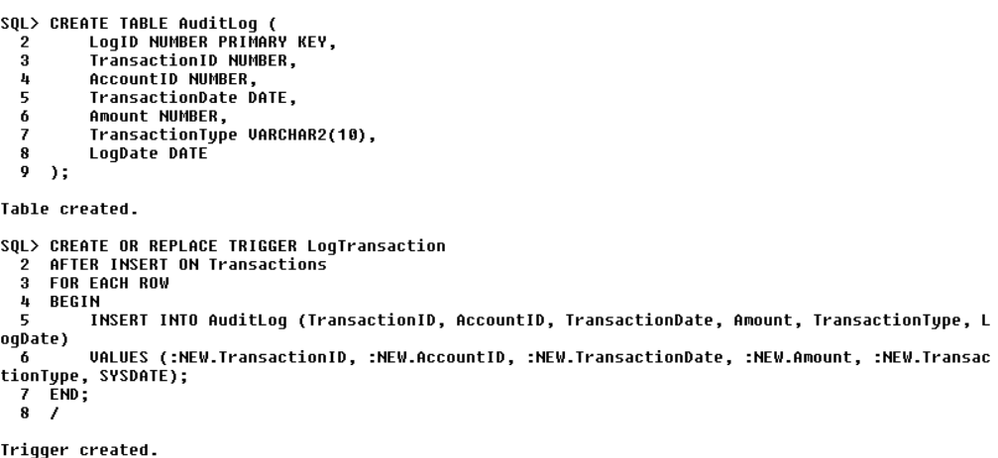

Testing the trigger

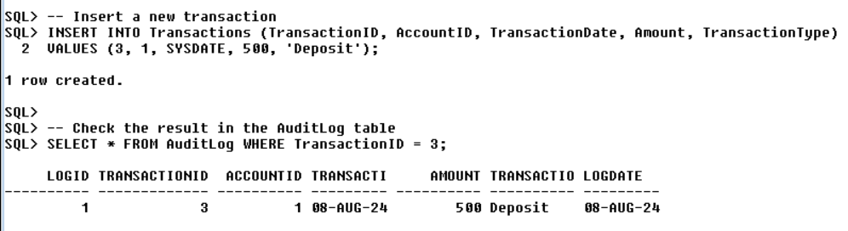

**Scenario 3: Enforce business rules on deposits and withdrawals.**

**Question: Write a trigger CheckTransactionRules that ensures withdrawals do not exceed the balance and deposits are positive before inserting a record into the Transactions table.**

Trigger Creation

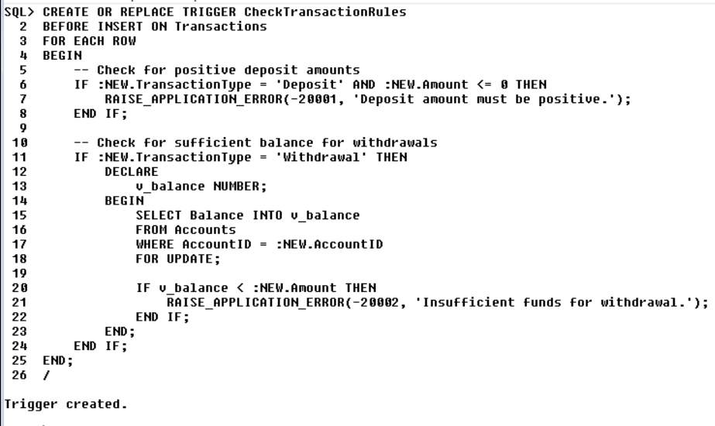

Testing Trigger:

